Birthday Tracker
ICTPRG418

Student: << Tri Tran >>
Student Number: << 470 890 859 >>
Date: << 24/08/2021 >>

Unit: ICTPRG418
Teacher: Troy Vaughn

Contents

IPO Chart 4
TOE Chart 5
Stylised Data Flow 5
Selected Pseudo Code 6
Displaying and Saving Records 6
displayEntry (CurrentEntry) 6
SaveEntry (CurrentEntry) 6
File data handling methods – read and write file 7
ReadFile 7
WriteFile 7
Navigation Button Code 8
First 8
Last 8
Previous 8
Next 9
Navigation Button Code 10
New 10
Save 10
Exit 10
Delete 10
Find 11
Structured Chart(s) 12
Managing the GUI elements 12
Managing the user Actions 12
Class diagram 13
Testing 14
Test Plan 14
Test Cases: 15
Evidence of Debugging 16
System generated program documentation 17
User Manual for: Sample IP Database 18
Example 1 … (Partial sample only) 18
Example 2 … (Partial sample only) 19

`

Additional instructions for completing this document for Assessment Task 1 (Java 1):
- Add your name on Page 1.
- The IPO and TOE charts, and the Pseudo code can be left much as they are. (Change PCName to the first field of your assignment, PCID to your second field, and IP to your third field.)
- The current images for the data flow and structured charts can be left as they are.
- Update the Class Diagram:
  - Use the ESSModel.EXE utility provided in the third party materials (\JAVA1_Mark\ThirdPartyMaterial\EssModel_binary_22\EssModel.exe).
  - Once you have started the ESSModel.exe utility, use the File - Open Folder menu option to find the folder that has your Local Recycler's source code (\NetBeans Projects\ LocalRecyclers\scr\...)
  - Use options within the Diagram menu at the top of the screen to copy the Class Diagram to the clipboard or to an image file so that it can be pasted into your technical documentation.
- Read the information on Testing and then (on the page following the Testing information) prepare a brief Test Plan and then copy and paste data (as part of your Test Cases) that you may have used in your sample data file and may have entered on screen to test your program. Add some sample data that you may have found that caused errors in your program. Follow the instructions and headings provided in this section.
- In relation to Debugging:
  - Click on a line number next to a line of code (for example in your ReadFile code).
  - Then use options within the Debug menu (at the top of the NetBeans screen) or options among the Debug toolbar options, to debug a small section of your program.
  - One of many instructional videos offered on YouTube in relation to debugging is: https://www.youtube.com/watch?v=2Z9B8wYhKWw
  - Use the Print Screen button on your keyboard to capture two (2) screen images and paste them into your program documentation.
- Javadoc:
  - You are able to generate Java technical documentation for your program using the following menu option in NetBeans: Run - Generate Javadoc
  - This menu option will generate Javadoc HTML documentation in a dist folder in your Local Recyclers NetBeans project.
  - When you zip up your NetBeans project file to hand in, your Javadoc documentation will be automatically included in the zip file.
- Prepare a one page User Manual for your Local Recyclers project - I have demonstrated a couple of options at the end of the template document.
- I am anticipating that the filling in of this template document for Java 1, Assessment Task 1 (only) should take up to about 2 hours to complete. Please get back to me should you find you require more time than this.
- When your project and document are complete:
  - Copy this technical documentation file into your NetBeans Assignment project folder.
  - Zip up your completed project - with all the other project files and folders contained within it.
  - Rename this zip file: Surname_StudentNumber_ICTPRG418_AT1.
  - Upload to Connect - ICTPRG418 - Assessment 1.

IPO Chart

Input | Process | Output | Storage
‘Records’ (entries) from the data file:  - Name  - Likes  - Dislikes  - BirthdayDay  - BirthdayMonth | - Open the file  - Read the first entry  - If not all entries have been loaded, load the next entry  - Record the total number of entries read in. | - Show first record (entry) on screen | Data File  Temporary storage in RAM memory
- New button, then…  - Name  - Likes  - Dislikes  - BirthdayDay  - BirthdayMonth  Then,,,  - Save button | - Clear the screen ready for new record to be entered.  - Allow user to enter information  - Save the record (entry) back to RAM memory | New record (entry):  - Name  - Likes  - Dislikes  - BirthdayDay  - BirthdayMonth | Updated records temporarily stored in RAM memory
- Search String and Find button | - Go through the record (entry) list until the Name matches the entry in the Search text field. | Record (entry) is shown on screen
- Record (entry) to be deleted presented on screen and then the Delete button. | - For all entries after the current entry, move the other entries up the list, therefore removing the current entry.  - Set the number of entries in the list to current number – 1. | Present the next record (entry) after the deleted one. | Updated records temporarily stored in RAM memory
- Save button | - Save all the entries in RAM Memory into the specified output file. | Export of all records (entries). | All entries saved in a new copy of the data file.
- Exit button | - Save all data (as per Save button) and…  - Close program | Export of all records (entries). | All entries saved in a new copy of the data file.
- Binary Search button | - Takes the array and looks at middle element, then determines whether the value it is looking for is higher or lower in the collection.  - Then eliminate the irrelevant higher or lower portion before repeating the process on the remaining values until it finds the entry it is looking for | Show the entry element number entered by user
- Month Search button | - Go through the entry list and find the matching month in the text field below the button | - Display names, likes, dislikes day and month of birthday in the Birthday List text area

TOE Chart

Task | Object | Event
Load Name, Likes, Dislikes, BirthdayDay and BirthdayMonth | Form | Open
Clear screen ready for new entry | New button | Click
Save the current entry and then all entries to a clean copy of the data file | Save button | Click
Find the current entry | Find button | Click
Delete the current entry | Delete button | Click
Locate the first entry in the list and display it on screen | First (|<) button | Click
Locate the previous entry in the list and display it on screen | Previous (<) button | Click
Locate the next entry in the list and display it on screen | Next (>) button | Click
Locate the last entry in the list and display it on screen | Last (>|) button | Click
Save the current entry, then save all entries to a clean copy of the data file, and then close the program. | Exit button | Click
Takes the array and looks at middle element, then determines whether the value it is looking for is higher or lower in the collection.  Then eliminate the irrelevant higher or lower portion before repeating the process on the remaining values until it finds the entry it is looking for | Binary Search button | Click
Locate birthdays in a particular month | Birthday Month button | Click

Stylised Data Flow
***leave as is

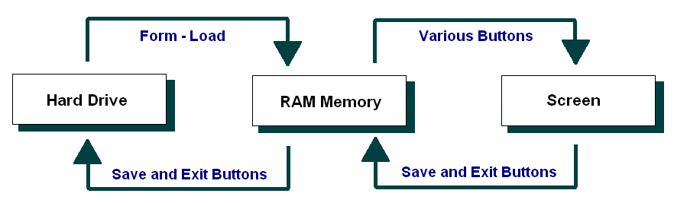

Selected Pseudo Code

Creating buttons, labels, textfields and layout

DECLARE all the buttons needed for the programs as variables, call these btnExit, btnFirst, btnLast, btnNext, btnPrevious, btnFind, btnNew, btnSave, btnDelete, btnBinarySearch, btnMonthSearch;

CALL static method to create JButton from UIComponentLibrary class and pass in the parameters for these buttons (names, position x and y, layout, etc…)

DECLARE text fields named txtName, txtLikes, txtDislikes, txtBirthdayDay, txtBirthdayMonth, txtFind, txtBirthdaySearch;

CALL static method to create JTextFields from UIComponentLibrary class and pass parameters

DECLARE labels named lblTitle, lblName, lblLikes, lblDislikes, lblBirthdayDay, lblBirthdayMonth, lblBirthdayList, lblFind;

CALL static method to create JLabels from UIComponentLibrary class and pass parameters

DECLARE Springlayout variable and call it in the class (JFrame)

Displaying and Saving Records

In line with our earlier data flow diagram and structured chart, we might start with a couple of the supporting methods that are called repeatedly.

In particular, let’s plan the method that Displays a Record, and the one that updates a record in RAM memory.

The pseudo code for these might be as follows:

DECLARE a 2D Array to hold maximum of 5 entries for each text field

DECLARE an integer called maxEntries and set to 100. This sets the max amount for this Birthday Tracker

DECLARE an integer called numberOfEntries, to track amount of entries currently in the database to use for delete, save, and navigation functions

DECLARE an integer called currentEntry to display the current entry

DisplayEntry (CurrentEntry)

SET the Name variable stored from reading csv file to the Name text field

SET the Likes variable stored from reading csv file to the Likes text field

SET the Dislikes variable stored from reading csv file to the Dislikes text field

SET the BirthdayDay variable stored from reading csv file to the BirthdayDay text field

SET the BirthdayMonth variable stored from reading csv file to the BirthdayMonth text field

SaveEntry (CurrentEntry)

SET the Name from the Name text field to the index of Name in the 2D Array of CurrentEntry

SET the Likes from the Likes text field to the index of Likes in the 2D Array of CurrentEntry

SET the Dislikes from the Dislikes text field to the index of Dislikes in the 2D Array of CurrentEntry

SET the BirthdayDay from the BirthdayDay text field to the index of BirthdayDay in the 2D Array of CurrentEntry

SET the BirthdayMonth from the BirthdayMonth text field to the index of BirthdayMonth in the 2D Array of CurrentEntry

File data handling methods – read and write file

Next let’s turn to the file handling methods.

The pseudo code for these might be as follows:

ReadFile

IF there is an error, then go to the ErrorHandler

OPEN the data file ready for reading
SET counter = 0
WHILE there is more data
Read in a line of data
Put the entries in their respective arrays
Set counter = counter + 1
END While
SET the NumberOfEntries = counter
CLOSE the data file

ErrorHandler:
Write the message: “There was a problem in loading the data in the data file”

WriteFile

OPEN the data file for writing data
For all entries in the arrays (For count = 1 to
numberOfEntries)
Write a line of data into the data file
END For
Close the data file

Navigation Button Code

The navigation buttons - First, Last, Previous and Next - require code within the ActionPerformed method, calling other methods if/as required.

The pseudo code for these buttons might be as follows:

First
SET the CurrentEntry = the first record in the array
CALL: displayEntry(CurrentEntry)

Last

SET the CurrentEntry = the last record entered into in the array
CALL: displayEntry(CurrentEntry)

Previous
SET the CurrentEntry = the CurrentEntry - 1 in the array
CALL: displayEntry(CurrentEntry)

That said, we need to check if we have gone past the beginning of the array... We therefore could adjust the pseudo code to test for this:

IF CurrentEntry > first (0 for Java), then:
Set the CurrentEntry = the CurrentEntry - 1 in the array
Call: displayEntry(CurrentEntry)
END If

Next
SET the CurrentEntry = the CurrentEntry + 1 in the array
CALL: displayEntry(CurrentEntry)

Again we need to check if we have gone past the last record (numberOfEntries) in the array... We therefore could adjust the pseudo code to test for this:

IF CurrentEntry < NumberOfRecords, then:
Set the CurrentEntry = the CurrentEntry + 1 in the array
Call: displayEntry(CurrentEntry)
END If

Note: The last record (last data entry) may be well short of the full size of the array. For instance there may be 67 computers in the arrays, but the arrays might hold up to 500 or 1000 entries.

Navigation Button Code

The remaining buttons – New, Save, Exit, Delete, Find, Binary Search and Month Search - require code within the actionPerformed method.

The pseudo code for these might be as follows:

New

IF the arrays are not full
Increment NumberOfEntries
Set the current record to the last record
Clear the array entries for the current record
Display the current record
END if

Save

SAVE the current record

Exit

WRITE the array data to the data file
QUIT the program

Delete

FOR all records from the current to the last record
COPY the next Name to the current record
COPY the next Likes to the current record
COPY the next IPAddress to the current record
END For
Decrement the NumberOfEntries
If the current entry is now past the new last entry
Set the current record back one
END if
Display the current entry

Find

SET found = false
SET counter = o
While you have more records to check and the entry has
not been found
If the current entry is equals to the search string
Set found = true
End If
Increment the counter
END While
If Found
Set the current record to the one that was found
Display the current entry
END if

Binary Search

*** Find out fill in later

Month Search

LOAD csv file into 2D Arrays

WHILE monthSearchJTextField is not equals to 2D Array month field

Go through 2D Array until it is equal to the month search text field

DISPLAY all the names, months, like and dislikes matching the month search into the Birthday List text area
END WHILE

Structured Chart(s)

Managing the GUI elements
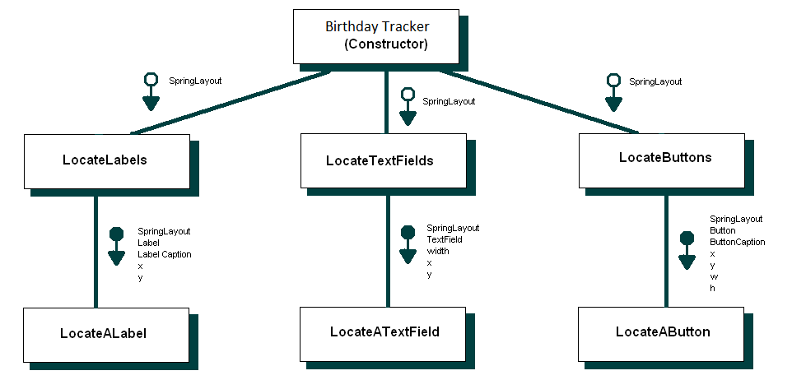

Managing the user Actions

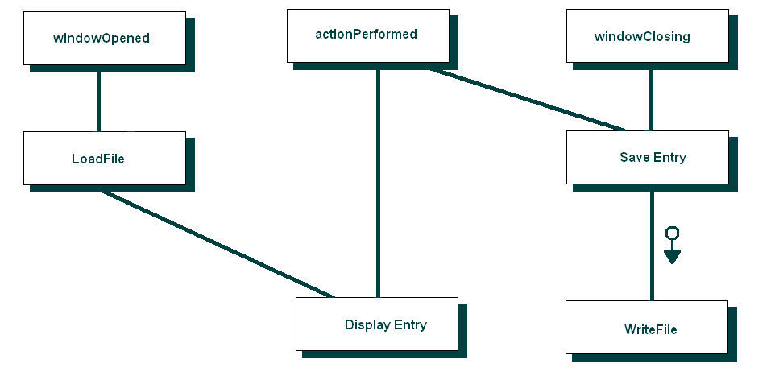

Class diagram
(Using ESSModel.EXE (supplied in Third Party Material)): *** use that for your java program and screenshot it and zip it in the submission

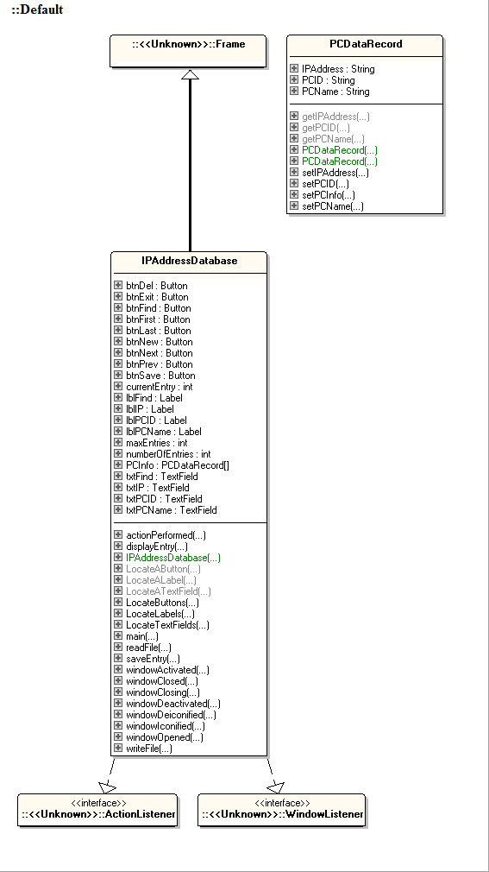

Testing

Test Plan

NOTE: the detail on this page is for reading (and review) only.

The approach to testing that will be used is as follows:

- Review the project requirements
- Prepare a solution design
- Develop the required application.
- Unit testing – test each component (method / class) as it is being developed
- Integrated Testing - Prepare a set of data (test cases) to check how the application will behave when appropriate data is read in and entered via the screen.
- Prepare several sets of data (test cases) to check how the application will behave when data that will generate exceptions is read in from the data file.
- Enter several sets of data (test cases) to check how the application will behave when data that will generate exceptions is entered via the screen.
- System Testing – Deploy the application to a computer system / network / web host site similar to that of the client’s and retest selected test cases.
- Acceptance Testing - Deploy the application to the client’s computer system / network / web host site and look to the client to retest using sample live data.
- Archive the test plan, test cases and results to an appropriate backup location.

Regarding the Test Plan below:

- Provide detail against each of the Test Plan headings. The goal is to indicate what and how you would be planning to complete your program testing.

Test Plan:

Test Objectives (What is your testing aiming to achieve?)\

The primary goal of the test plan is to achieve a production ready version of the birthday tracker. A production version ready of this version includes:
- All navigations buttons working properly (previous, next, first, last)
- Search buttons are correctly working (Binary search, month search, find search field)
- Functional buttons are correctly working (New, Save, Delete)
- Exit button is working

Test Strategy (How do you aim to complete your testing?)

Test strategies include:
- Testing buttons independently
- Clicking on navigation buttons to make sure they are navigating through the database
- Click on Exit button to test if it closes application
- Click on delete button then check csv file has correctly removed data
- Click on save button then check csv file has correctly saved data
- Use Search buttons and ensure they are finding the right entry

Resource Requirements (What personnel, computers, software, etc, will you need to complete your testing?)

Resource requirements include:
- Windows operating system on a mid-high range computer capable of efficiently writing and running code
- IntelliJ IDE
- Java SDK
- Developers

Roles and Responsibilities (Who will be involved and what will be their respective roles?)
***either me or another person, what is their goal?

Tri – Developer and tester, primary role is to write the code for the application, test and debug application.

Bug Reporting (How will you be providing the results of your testing to your manager and/or the development team?)

Test results will be provided in the form of reports, emails, screenshots and meetings.

Regarding the Test Cases below:

- Note that the headings are a guide only.
- In the first section you might copy and paste the content of your current sample data file.
- In the second section you could re-copy your data file content, but edit it such that it would cause errors or exceptions.
- In the next sections you could copy screen images of your program maybe showing sample data entry.
- If you were, for example, to click on the NEW button multiple times, this would create blank entries in your data. People using your program might consider this to be an exception (not preferred).
- Note: I am not requiring you to fix such issues, but maybe just comment on them.
- You can add a summary of your testing at the end of the testing section.

Test Cases:
*** think about a few more interesting test methods, like click on new button multiple times, not required to fix just comment on them

How I tested the reading in of the data from the data file:

- Created a txt file with comma separated values with dummy data such as “John, Cars, Music, 25, February” and run the application to see if the data has correctly loaded into the text fields.
- One dummy data had an empty field on purpose and it _ _ _ ***fill in when you try it

How I tested the writing out of the data to the data file:

- Started the application with empty fields, filled out the text fields with information and clicked saved.
- Check the csv file to see if the data has correctly saved, also restart the application and check if the newly written data has correctly loaded into the database

How I tested the various navigation buttons:

- Open the csv file and the application side by side, click on First, Previous, Next and Last buttons to see if they correctly correspond to the csv files

How I tested the program’s ability to add new and edit existing entries:

- Started the application with empty fields, filled out the text fields with information and clicked saved.
- Check the csv file to see if the data has correctly saved, also restart the application and check if the newly written data has correctly loaded into the database

How I tested the program’s sort, search and filter facilities:

- Tested Month Search function by opening the csv file and application side by side, search for all the birthday months in January and check the csv file to see if the application correctly displays all the data of the birth month of January.

- First left the text field empty and pressed Birthday Month search button, nothing happens, fixed by adding an if statement to print an error message

- Test typing lower case letters and it did not find any month, fixed it with .equalsIgnoreCase() method

- Tested if I had two of the same name (“Adam”) in the library, when I pressed Find button it only finds the first Adam and it stops even if the Find button is clicked again.

- Tested if the Find text field was empty, I added an error popup message to tell the user to enter a valid name.

Evidence of Debugging

Two to three screen images demonstrating debugging:

*** similar to c#, use debugger, use breakpoints, hover mouse over variables and screenshot
<< Copy Screen Images here >>
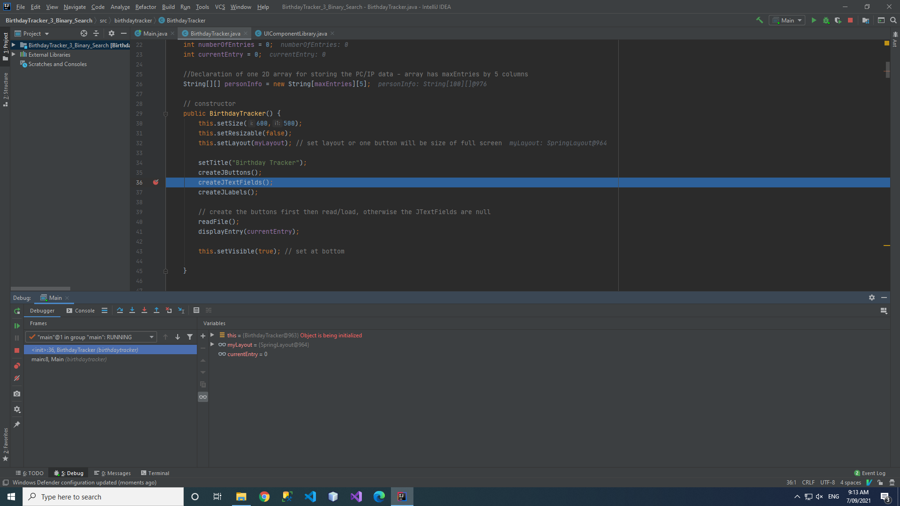
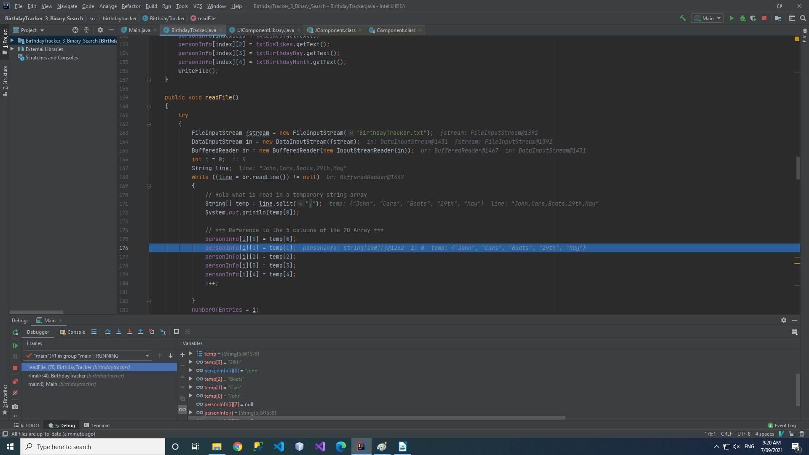

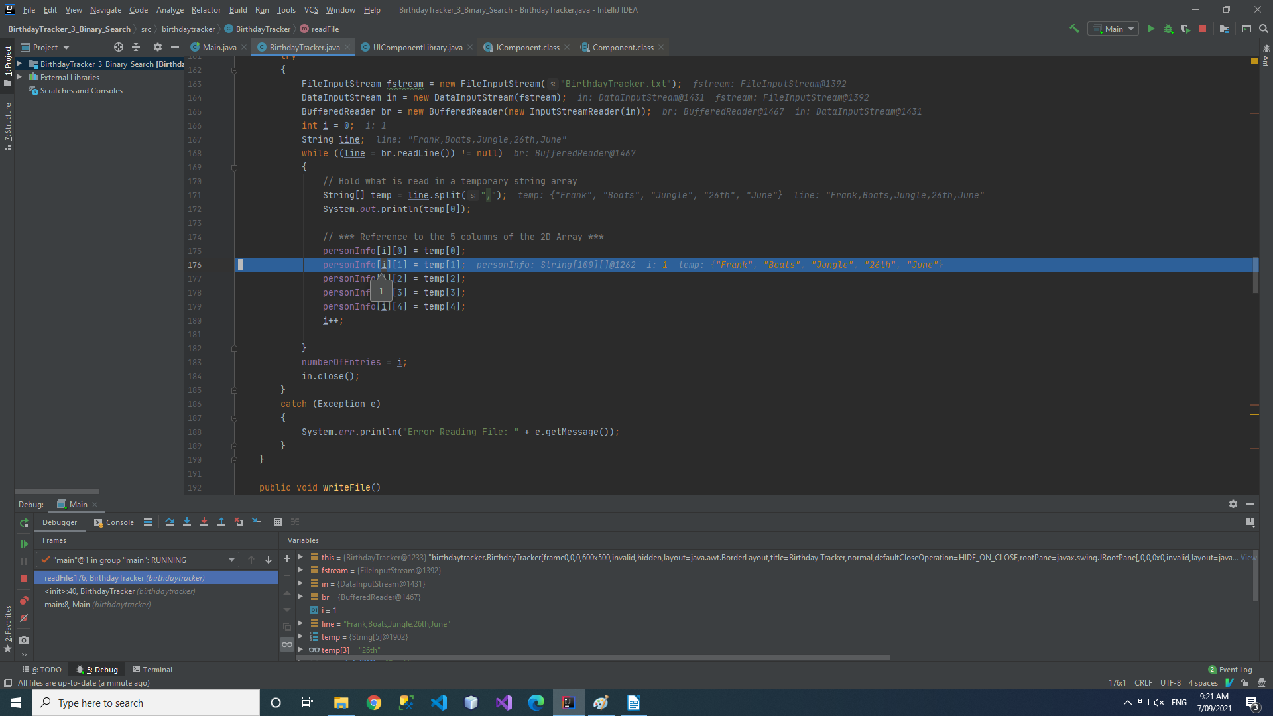

System generated program documentation (Javadoc)

Prepare automated program documentation using a facility provided within your IDE,
such as Javadoc, or using a third-party product such as ESS Model.

Ensure this automated documentation is provided within your submission.

***use ESS software, then zip the file with the submission

User Manual for: Sample IP Database
Prepared for: Birthday Tracker
Type a search string in the Search text box sand click the Find button to locate an existing person’s entry.

If more than one of the same name exist keep pressing find to cycle through the searches
Author: Tri Tran
Date Prepared: 24/08/2050

Main Menu
Click Save button to save the a new entry or update an existing entry

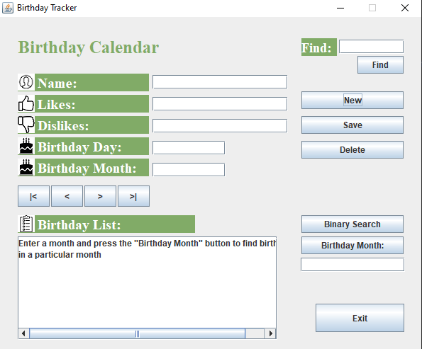

Click Navigation buttons to navigate to first, previous, next and last entries
Click the New button to add a new person’s entry

Click Delete button to delete the current entry

Click Birthday Month button to find a list of people that has birthdays in the same month
Click Binary Search button to find the index of particular entry

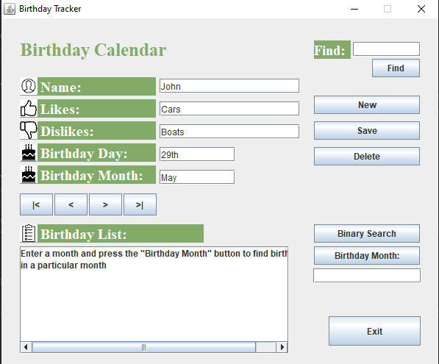 | Features by Component/Button  Application Opens: Load person’s record  Application closes: Automatically save entries to the .txt file  New button: Clear screen ready for new entry  Save button: Save the current entry and then all entries to clean copy of the data file  Find button: Use in conjunction with the Search text box to find an existing entry  Navigation buttons (<| , < , > , >| ): use these first, previous, next, last buttons to navigate through the existing database  Binary Search button: Show the index position of an entry based on the Name  Birthday Month button: Type in a month, filter through database and display every person that has birthdays in that month  Exit button: Exit the application  Delete button: Delete the current entry the user is on
How Do I?  Add and Save a New Entry  - Click on the New Entry button  - Type in your new entry  - Click on the Save button to save the entry | How Do I?  Find and Update an Existing Entry  - Type the PC Name  - Click on the Find button  - Check the entry presented is correct  - Edit the entry as required  - Click on the Save button to save the entry  Find an entry by Name  1. Type the name of the person you want in the find area  2. Press Find button
Find a list of people that has birthdays in a particular month  1. Type in the month you want to search by in the month search text area  2. Press Birthday Month search button | Delete an entry  1. Press Delete button and it will delete the current entry the user is on

Evidence of correspondence with your Manager

Maintain appropriate ongoing communication with your manager.
This can be done with a series of applicable emails.

- Email your manager before the commencement of this project to secure the project specification and the organisation’s programming and documentation standards.
- Prepare a closing email to your manager regarding the success of your project development endeavours. You should suggest any areas of concern or risk to your manager for inclusion in the development team’s risk matrix.

To: Project Manager / Manager
From:
CC:
BCC:
Date: 19/07/2023
Subject: Request for Program Specifications and Standards

-------------------------------------------------------------

Hi <Project Manager>,

Regarding… the Program Specifications and the Organisation’s Programming and Documentation Standards
*** what does the program need to do, what documentation do we need, what programming language are we using, what standards and conventions are we using

Regards,
<Lead Developer>

----------------------------------------------
< Lead Developer >
Lead Developer@BusinessName.com.au
-----------------------------------------------

To: Project Manager / Manager
From:
CC:
BCC:
Date: 10/09/2023
Subject: Project Success and Information

-------------------------------------------------------------

Hi <Project Manager>,

Regarding… the project’s success / outcome…
*** this is what happened with the project, its successful, built it, test it, had few small bugs, fixed them and ready to give to customer

Regards,
<Lead Developer>

----------------------------------------------
< Lead Developer >
Lead Developer@BusinessName.com.au
-----------------------------------------------

